**Self-Study Summary**

**ACGME International**

**Directions:** After completing the Self-Study, provide responses to the eight questions below.

The deadline for uploading the Self-Study Summary into the Accreditation Data System (ADS) is the Self-Study Due Date indicated on the program’s overview page in ADS.

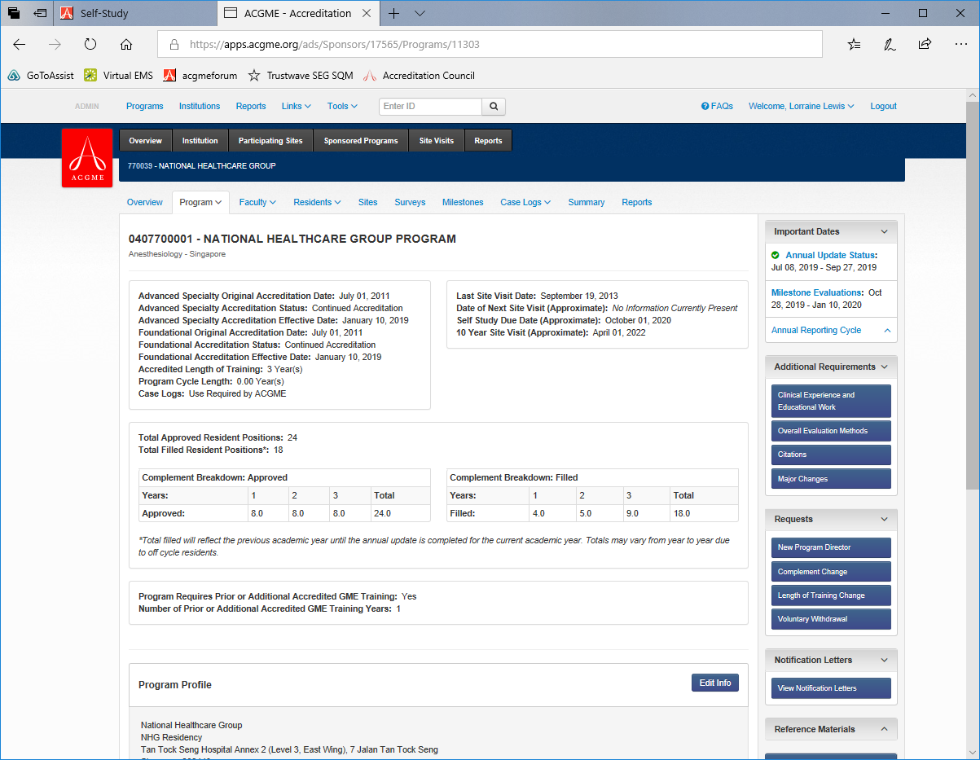

The responses provided will be used to assess the program’s aims, as well as the process used for the Self-Study, and how that process has supported program improvement.

Do not include information on areas that need development or improvement that were identified during the Self-Study process. Prior to the seven-year site visit, ACGME-I will request a summary of improvements and accomplishments that resulted from the program’s improvement plan.

**Program Name: _________________________________________**

**Program Number: _______________________________________**

**Self-Study Date (Month, Year):_____________________________**

***Program Description and Aims***Describe the program and its aims, using information gathered during the Self-Study.

1**.** Provide a brief description of the program, as you would to an applicant or a prospective faculty member. Discuss any notable information about the program. (Maximum 250 words)

|  |
| --- |
| Click here to enter text. |

2. Describe the program’s aims. (Maximum 150 words)

|  |
| --- |
| Click here to enter text. |

3. Describe any real or potential significant threats facing the program. (Maximum 250 words)

|  |
| --- |
| Click here to enter text. |

***Significant Changes and Plans for the Future***

4. Describe significant changes and improvements made in the program over the past five years. (Maximum 250 words)

|  |
| --- |
| Click here to enter text. |

5. Share the vision and improvement plans for the program for the coming five years. What will take this program to “the next level”? Discuss what the “next level” will look like, the envisioned steps and activities to achieve it, and the resources needed. (Maximum 350 words)

|  |
| --- |
| Click here to enter text. |

***Self-Study Process***

6. Provide information on the program’s Self-Study, including who was involved, how data were collected and assessed, how conclusions were reached, and any other relevant information. (Maximum 300 words)

|  |  |
| --- | --- |
| Who was involved in the Self-Study (by role/title)? | Click here to enter text. |
| How were areas that need further development prioritized? | Click here to enter text. |

7. If applicable, describe the role of the core program in the Self-Study(ies) of its affiliated subspecialty fellowship program(s). (Maximum 150 words)

Note: If this is an individual core residency program without associated subspecialty programs or a dependent freestanding subspecialty program, skip to 8.

|  |
| --- |
| Click here to enter text. |

8. Describe learning that occurred during the Self-Study. *This information will be used to identify potential best practices for dissemination.* (Maximum 200 words)

|  |
| --- |
| Click here to enter text. |